**SACR CO-Reference Tool**

**User Guide**

**1 Initializing environment:**

Before starting, please make sure you have an Azure account, and you remember your signing in information.

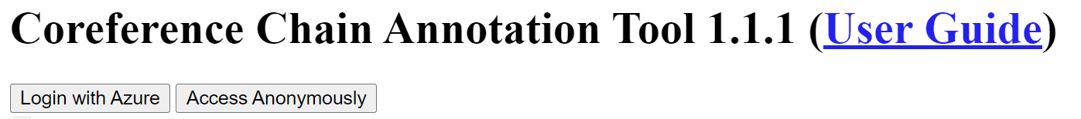App main window:

You should press on “Login with Azure” button then, sign into azure, and you will be redirected to a list of files that was assigned to you.

You can open a file by clicking on its name. (it might take a second).

**2 The Workflow:**

* **2.1 Main window** - main interface. It is composed of the following elements:
* Text and metadata.
* Potential Mentions / Regions (the referring expressions), Sets (coreference relations).
* As you can see, there are no control buttons. Commands are activated by clicking on keys on your keyboard.
* Press ‘h’ to display all available commands.

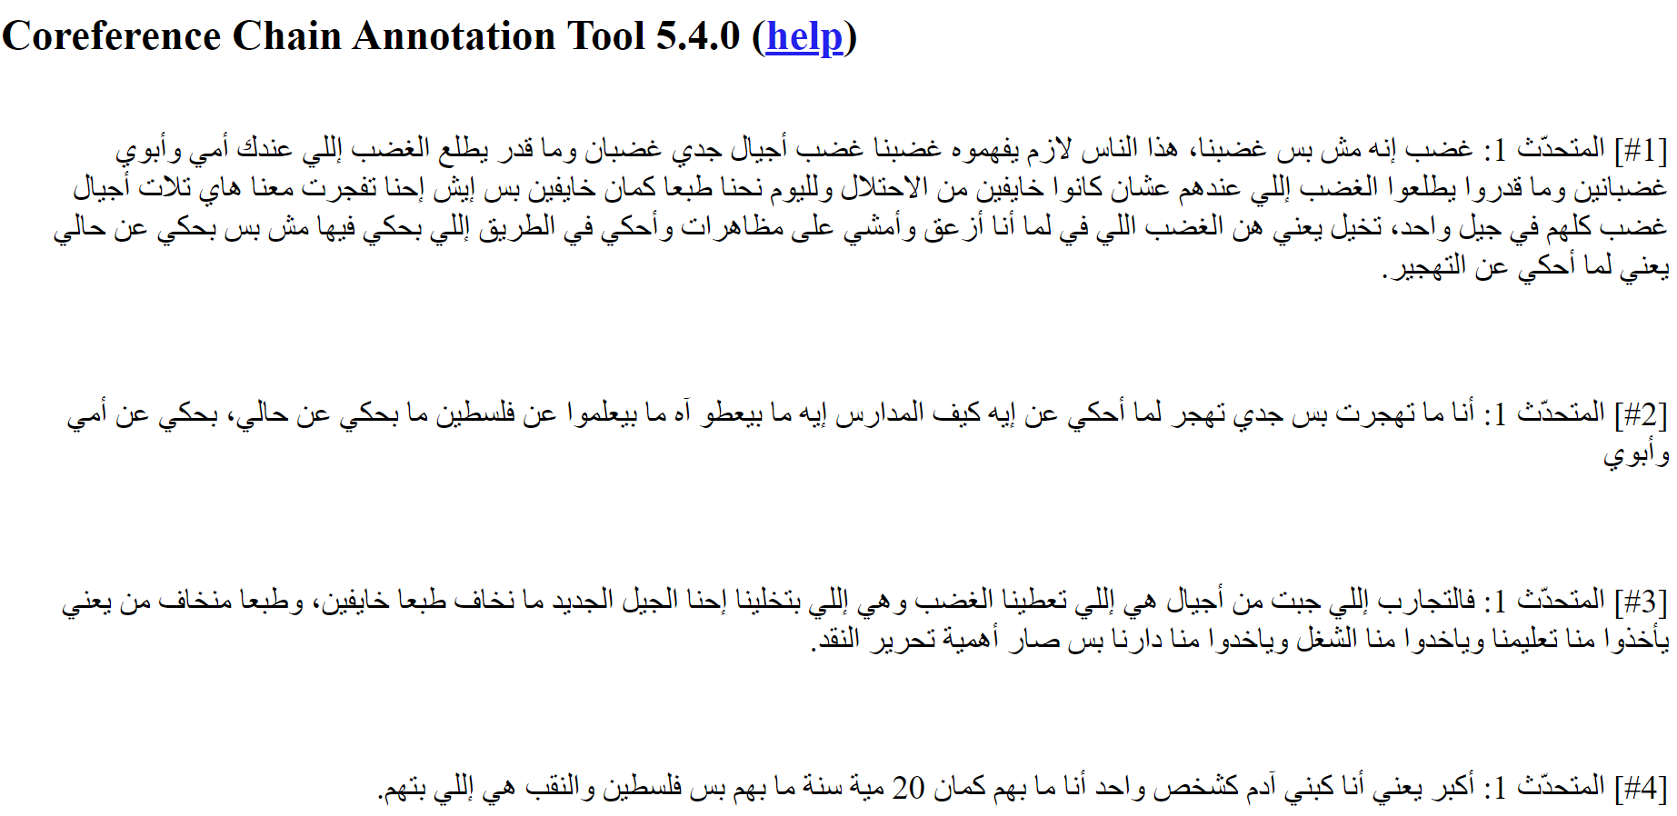

* **2.2** **Creating mentions, sets, and chains.** *(pages 13-19 in the user guide (points 5 to 5.7)*
* First, we want to create the mentions, this can be done in a few ways, feel free to choose the fastest one for your convenience.

1. Creating an unnamed expression by clicking the first letter of the word/expression and then on the last letter of the word/expression (the expression will be underlined; to cancel and choose another word, just click again on it and it’ll be underlined). This will create an unnamed expression called ‘ $M_{i}$’. This later can be changed by selecting the mention and pressing ‘n’.
2. **Similarly, to 1, except this time we will hold the ‘Shift’ key while pressing, this will allow us to name the expression while we set it.**

* **Adding expressions to an existing set.**

Batch mode:

• select a mention,

• create mention as before, but hold ctrl: all the newly created mentions will be automatically

attached to the mention you selected in the first step.

Example of the batch mode:

• Let’s say you have the sentences: « Paul est heureux. Il est content. Il est joyeux. »

• Create a mention for « Paul » and then select it.

• Hold ctrl and double-click on the first « il » and the second « il ».

• Both « il » are attached to « Paul » : you have create the set « Paul... Il... Il... » with

a minimal effort!

Let’s say you have several mentions, and you want to group them (for example because they are

Coreferenti'al).

**5.2.1 Using drag-and-drop**

You just need to drag-and-drop one mention one over another. The mention that is attached to

the set will get the name of the set. If the set reach the critical size to be chain

then it will be colored.

1. Via PopUp window – will be discussed later.

* **Selecting a mention**

Don’t confuse « selecting (or clicking on) a mention » and « selecting (or clicking on) a word ».

You select a word by clicking on it: it is underlined. You do that to create a new mention (you

need to click on another word to complete the process). If you have selected a

word by error, just click on it a second time to deselect it.

To « select (or click on) a mention », you need to click on its name (the part with the colored

background) or anywhere on the white part inside the frame of the mention, except on a word

(in which case you select a word...). To deselect a mention, click on it.

See figure 7 for some examples.

When you select a word, all mentions are deselected, and vice-versa.

* **Detaching an element from a group**

Hold ‘Shift’ and click in the mention you want to detach, it’ll be grated and renamed with name as ‘ $M_{i}$’ – and that’s it is now a singleton.

* **Merging two sets**

Drag-and-drop the element of one set over the element of another set. You will ask if you

really want to merge.

The name of the resulting set is the name of the name of the source.

* **(Re)naming a set**

Select a mention of the set and press:

• N to change the name of the selected chain (don’t ask, use the content of the selected mention),

• n to change the name of the selected chain (ask, default is current name),

• m to change the name of the selected chain (ask, default is the content of the selected mention).

**Changing the color of a chain**

Select a mention of a chain and press ‘c’, then choose the desired color.

Reminder: a set has a color only if it is a chain, that is, a group of more than a single element. Other sets which are not chains are colored gray.

* **Additional examples and info can be found in 15-16**

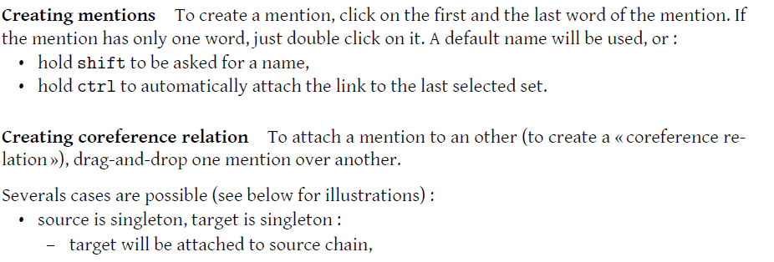

* **2.3 Popup window** – contains all the sets and chains that have been assigned so far.
* To open the window, we can press ‘p’ which will toggle a side panel with the list of sets and chains.
* Pressing 'e' and 'E' (shift + ‘e’) will switch between expanding and collapsing the list of mentions for each chain.
* 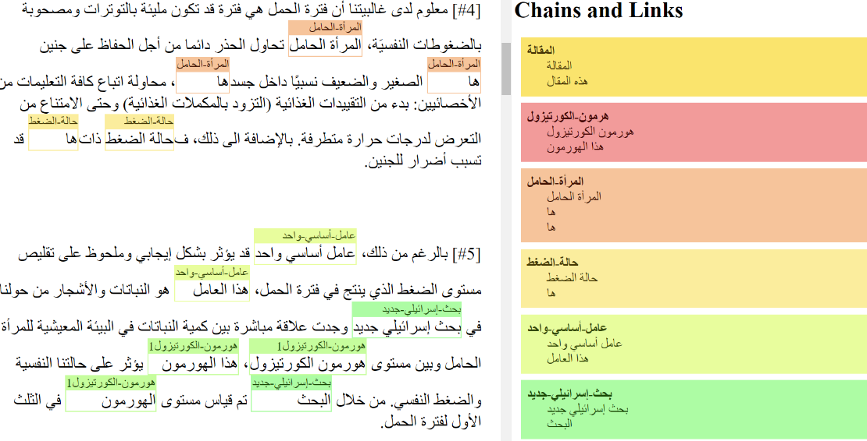**Working with the window –** we can modify our chains and sets via the properties window directly. This works similarly to the regular workflow, but it allows us more flexibility.

**3 Saving a document**

Before leaving the page, you need to save your annotations in a file. Just press “W” (shift + w) (as in « Write »).

Depending on your browser settings, the file will be saved automatically, and you’ll get a confirmation message.

The filename will include a time stamp (that is, the current date and time). This allows you to

save several versions of the same file.

**4 Additional Keys**

**Editing links** Use:

• suppr or backspace to destroy the selected mention,

• c to change the color of the selected set,

• N to change the name of the selected set (don’t ask, use the content of the selected mention),

• n to change the name of the selected set (ask, default is current name),

• m to change the name of the selected set (ask, default is the content of the selected mention).

**Navigating** Use:

• f to go forward in text,

• F to go forward in text (only visible),

• j to go forward in set,

• J to go forward in set (only visible),

• b to go backward in text,

• B to go backward in text (only visible),

• k to go backward in set,

• K to go backward in set (only visible),

• t to scroll to the selected mention in the main window,

• T to scroll to the selected mention in the popup window.

**Showing and hiding mentions** Use:

• o to show only the set of the selected mention,

• O to show all mentions,

• s to show the search box,

• u to hide non chains,

• U to hide/show (toggle) non chains in popup,

**Popup** Use:

• p to show the popup window of all sets and mentions,

• e to expand all sets in the popup,

• E to collapse all sets in the popup,

• v to expand chains in the popup.

**Saving** Use:

• w to write the text and annotations to a file,

• W save to Azure storage.

• x to write the schema to a file,

• X to show the schema (in a dialog).

**Displaying** Use:

• i to increase font size,

• I to decrease font size,

• l to show statistics,

• P to show chain patterns.